6th ANNUAL
Johnstown Little League Baseball
HIT-A-THON FUNDRAISER
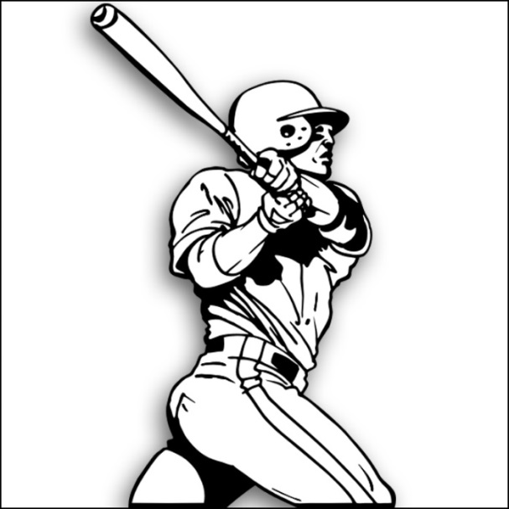 | J  Saturday, June 5th

TEAM | TIME | LOCATIONS
T-Ball  SPRITZER & DINGMAN  SCHRUM & PALMATEER | 9-10 AM  10-11AM | T-Ball Field
COACH PITCH  WILSON & MCCLEARY  MCCUMBER & HARTWIG | 9-10 AM  10-11AM | Bantam 2 Field  Bantam 2 Field
Minors  RIGOS & NGUYEN  STOCK | 9-10 AM  10-11AM | Minors Field
Majors  KLINGBEIL & HALL | 9-10AM | 50/70 FIELD
Softball (minors/majors)  EPLITE & BALDWIN | 9-10AM | Bantam 1 Field

All Players will receive a pledge sheet. To participate each player must get at least $10 worth of sponsors. Your sponsor sheet is your ticket into the Hit-A-Thon.
HIT-A-THON
PLAYER NAME

SPONSOR NAME PLEDGE AMOUNT
(Flat Donation/not per hit)

Prizes
- Top Pledge Sheets for each Division ($25 Gift Card)
- 1ST – 2ND -3RD Awards in each Division
Total Johnstown Little League Goal
$3,000

Hit-A-Thon
Point Chart

1 Point | 2 Points | 3 Points | 5 Points
Ground ball in the infield | Line drive or pop fly that lands in between back edge of infield and the white divider line | Line drive or pop fly that lands in between the white divider line and the fence | Home Run

